ETL Entity Load Procedures Task
The purpose of this task was to create repeatable ETL loading procedures for the entity tables in the bl_3nf layer by using data from the sa_cash_salesand sa_card_sales source tables.
During the task, I first checked the source and target table structures for every entity. Then, I identified the correct business keys, created functions to detect new records, and created procedures that load these records into the target tables. The procedures were designed to write execution details into a centralized log table, handle errors, and avoid creating duplicate records when they are executed multiple times.
The following entity tables were included in the implementation:
- bl_3nf.ce_ship_modes
- bl_3nf.ce_returned
- bl_3nf.ce_payments
- bl_3nf.ce_locations
- bl_3nf.ce_employees
- bl_3nf.ce_products
- bl_3nf.ce_customers_scd
A separate procedure was created for each target entity table. This approach made each procedure responsible for loading only one table.
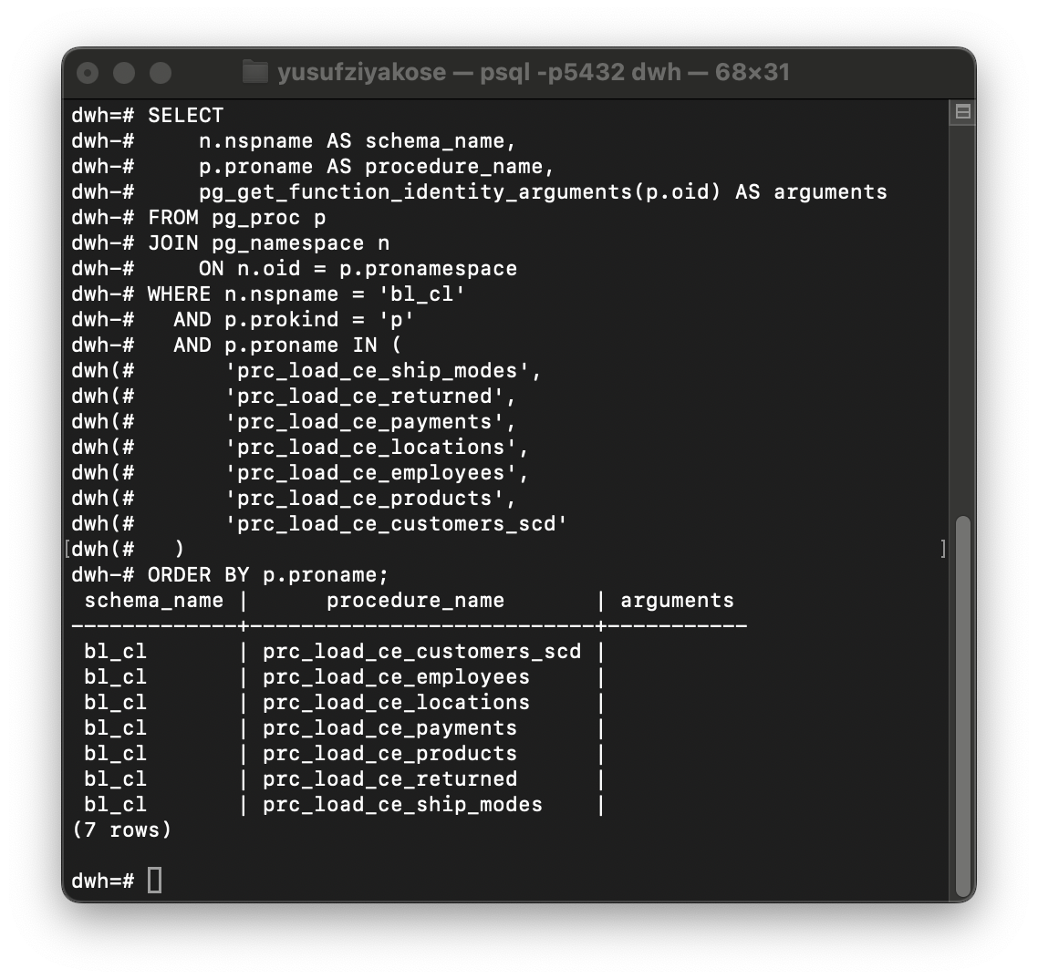

General ETL Approach
The following general approach was used in the procedures:
- Relevant data was extracted from the source tables.
- TRIM() was used on text fields to avoid problems caused by leading or trailing spaces.
- Source data was compared with the target table using the appropriate business key.
- New records were identified using a LEFT JOIN and WHERE target_id IS NULL pattern.
- New surrogate keys were generated for records that did not exist in the target.
- A FOR LOOP was used inside the procedures to insert new records.
- A SUCCESS record was written to the bl_cl.load_log table after a successful procedure execution.
- An EXCEPTION WHEN OTHERS block was added so that unexpected errors could also be written to the log table.
In addition, each entity table contains an unknown/default record with a surrogate key value of -1. The procedures check whether this record exists before loading new source data.

CE_LOCATIONS Process
The first important issue occurred in the CE_LOCATIONS table.
Location data contains the following attributes:
text
country
city
state
postal_code
region
At the beginning, there was a problem with the location business key format. The source key generated by the loading logic did not match the key format used in the existing target records. Because of this mismatch, some existing locations could have been detected as new records and duplicate rows could have been inserted.
After identifying this problem, I did not delete records immediately. First, a backup of the duplicate location records was created. Then, the source-target comparison logic was reviewed again.
The final solution was to compare locations using the actual location attributes instead of relying only on a generated string key. The comparison used:
text
country
city
state
postal_code
region
After correcting the logic, the location procedure was tested again. It returned 0 rows affected when no new source locations existed. This confirmed that the procedure no longer creates duplicate location records when it is executed again.
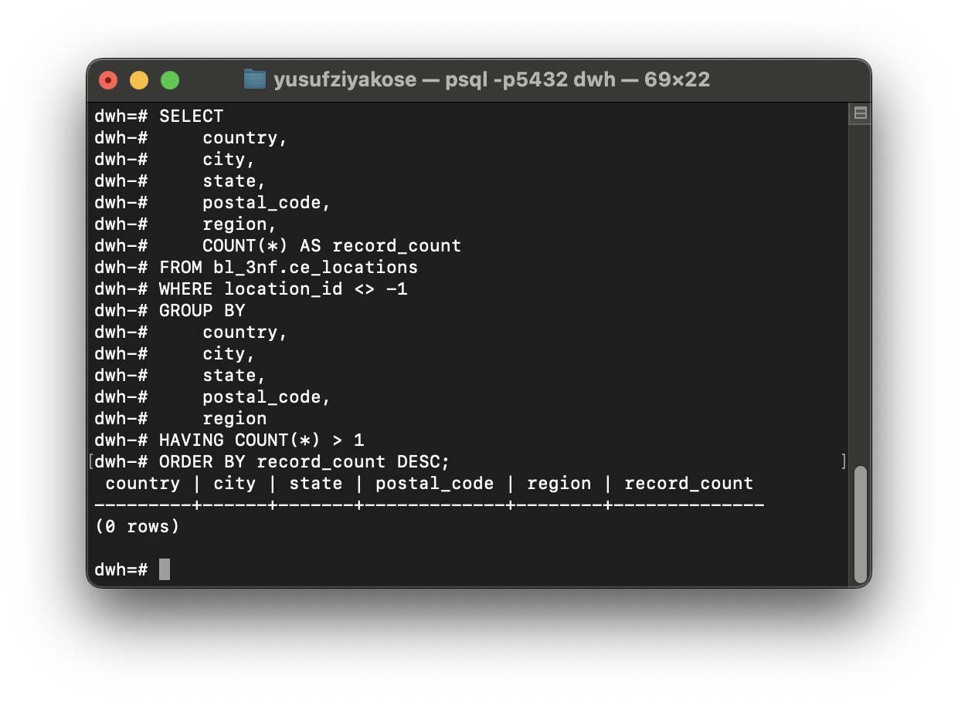
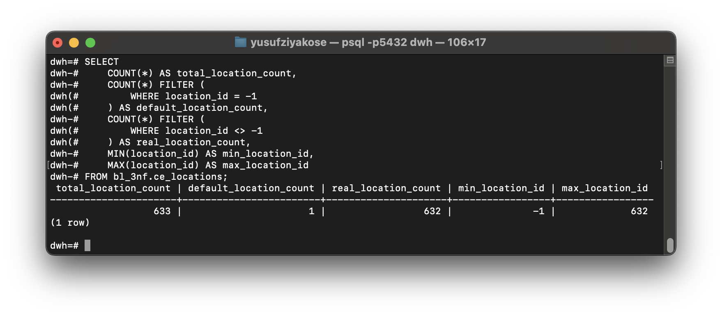

CE_EMPLOYEES Process
For the employee entity, the source tables contained the following columns:
text
employee_id
employee_name
The employee business key was selected as employee_id, not employee_name. Employee names can potentially change or be repeated, while employee IDs provide a more reliable unique identifier.
The business key mapping was defined as:
text
source.employee_id = target.employee_src_id
Five distinct employees were found in the source systems:
text
AJ-00001
CD-00004
DS-00002
EB-00003
OM-00005
All five employees already existed in the target table. It was also verified that there were no duplicate employee_src_id values in ce_employees.
During this stage, a syntax error occurred because a constraint query was pasted incompletely into the terminal. The error looked similar to this:
text
ERROR: syntax error at or near "tc"
This was not a database design issue. The beginning of the SQL statement was missing, so PostgreSQL could not parse the query. Once the query was reviewed, it was clear that the problem was caused by incomplete command input.
After creating the employee procedure, it was executed twice. Both executions completed successfully with 0 rows affected, confirming that no duplicate employees were inserted.

CE_PRODUCTS Process
For the product entity, source and target columns were compared and the business key was defined as:
text
source.product_id = target.product_src_id
The descriptive product attributes were:
text
product_name
category
sub_category
The source systems contained 1,895 distinct products. The target table also contained 1,895 real product records and one default product record.
During the duplicate check, another syntax error occurred because part of the query was pasted incompletely. The error was:
text
ERROR: syntax error at or near "oduct_id"
Again, this was not a problem with the database. The first characters of product_id were missing from the command. After running the complete query, it was confirmed that there were no duplicate product_src_id values in the target table.
Later, the source and target product attributes were compared. Three products appeared to have different product names, even though the names looked identical on the screen.
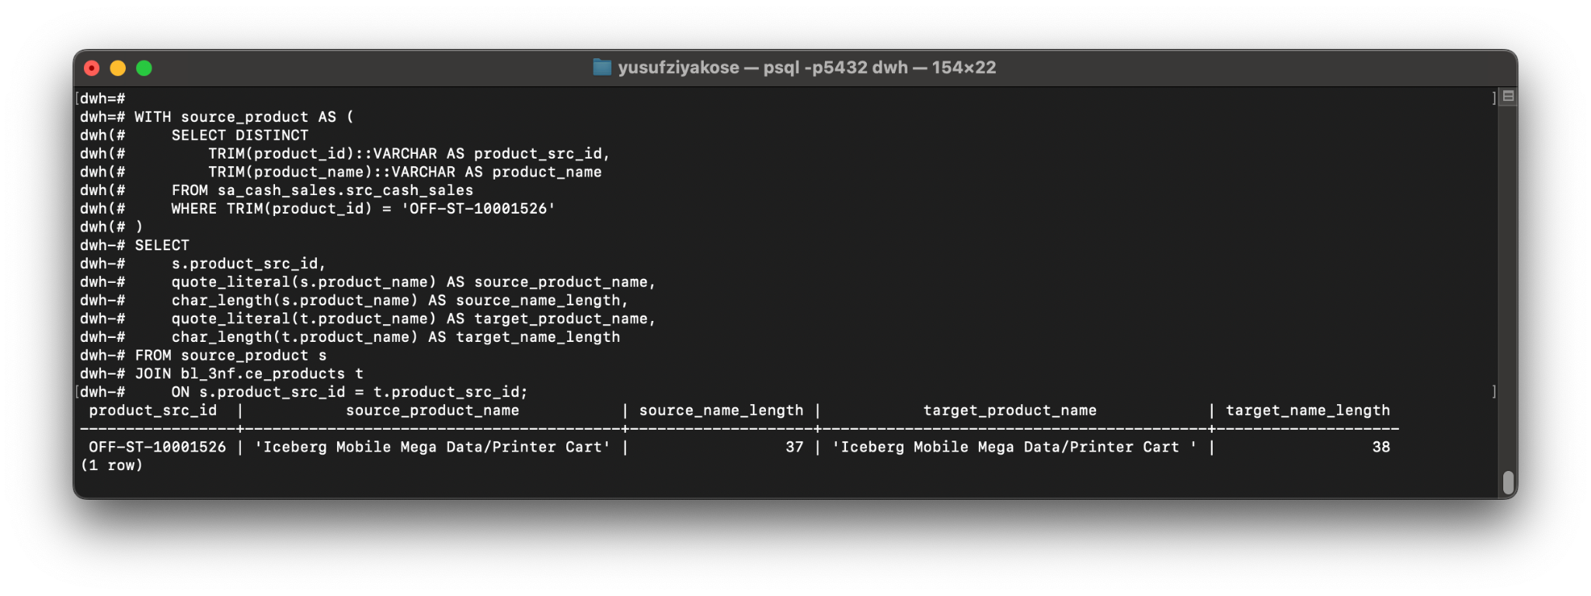

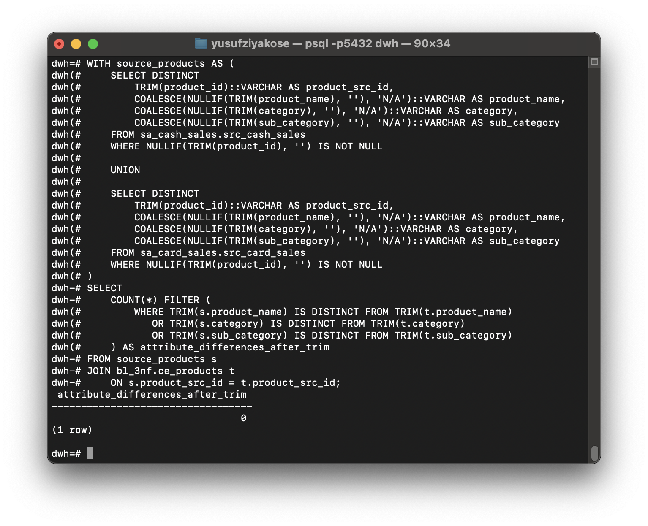

To investigate the issue, quote_literal, char_length, and octet_length were used. The results showed that the target values had an extra trailing space.
Example:
text
Source:
'Iceberg Mobile Mega Data/Printer Cart'

Target:
'Iceberg Mobile Mega Data/Printer Cart '
The difference was only caused by trailing whitespace. There was no actual difference between cash sales and card sales source data. After applying TRIM(), the number of attribute differences became zero.
For this reason, the new product loading function was created using TRIM()for all text fields. This prevents trailing spaces from creating data quality problems in future product loads.
The product procedure was executed twice. Both runs completed successfully with 0 rows affected.

CE_CUSTOMERS_SCD Process
The customer table was different from the other entity tables because it required Slowly Changing Dimension Type 2 logic.
The target table was:
text
bl_3nf.ce_customers_scd
The customer business key was defined as:
text
source.customer_id = target.customer_src_id
The attributes tracked for SCD Type 2 changes were:
text
customer_name
customer_segment
The target table contained the following SCD-related columns:
text
start_dt
end_dt
is_active
Existing active customer records had the following structure:
text
start_dt = 2026-07-30
end_dt = 9999-12-31
is_active = Y
The source systems contained 793 distinct customers. Each customer had only one customer name and one segment version in the source data.
The comparison between source customers and active target customers produced the following results:
text
Source customer count: 793
Active target match count: 793
Missing active customers: 0
Customers with attribute differences: 0
It was also checked whether any customer had more than one active SCD record. The result was 0 rows, meaning that there were no customers with multiple active versions.
To make the SCD design safer, a partial unique index was created:
text
ux_ce_customers_scd_one_active_customer
This index prevents more than one active record from existing for the same customer_src_id. Historical inactive records are still allowed, but only one active version can exist at the same time.
The SCD procedure follows this logic:
- If a customer does not exist in the target, a new active record is inserted.
- If a customer exists but customer_name or customer_segment changes:
  - The current active record is closed.
  - is_active is changed to N.
  - end_dt is set to CURRENT_DATE - 1.
  - A new active version is inserted with the updated customer information.
- If there is no change, no row is inserted or updated.
There were no new or changed customers in the current source data, so the function returned 0 rows. The customer SCD procedure was executed twice and both executions completed successfully with 0 rows affected.
This confirmed that the SCD procedure does not create unnecessary historical versions when no customer data has changed.

SOURCE_ID Column
A source_id column was added to CE_EMPLOYEES and CE_PRODUCTS to keep source metadata in a more consistent format.
However, this column was added after the original records had already been loaded. Therefore, the existing records still had empty source_id values. This was expected and was not considered an error.
New records inserted by the procedures will have the source_id populated.
For example:
text
employee_src_id = OM-00005
source_id = OM-00005
or:
text
product_src_id = FUR-BO-10000112
source_id = FUR-BO-10000112

Centralized Log Validation
All procedure executions were checked using the centralized logging table:
text
bl_cl.load_log
The latest log records showed the following results:
Procedure | Target Table | Rows Affected | Status

prc_load_ce_ship_modes | bl_3nf.ce_ship_modes | 0 | SUCCESS
prc_load_ce_returned | bl_3nf.ce_returned | 0 | SUCCESS
prc_load_ce_payments | bl_3nf.ce_payments | 0 | SUCCESS
prc_load_ce_locations | bl_3nf.ce_locations | 0 | SUCCESS
prc_load_ce_employees | bl_3nf.ce_employees | 0 | SUCCESS
prc_load_ce_products | bl_3nf.ce_products | 0 | SUCCESS
prc_load_ce_customers_scd | bl_3nf.ce_customers_scd | 0 | SUCCESS
The value rows_affected = 0 does not mean that the procedures failed.
It means that there were no new or changed source records to load. It also confirms that the procedures do not insert duplicate records when they are executed again. Therefore, the procedures are repeatable and idempotent.

Conclusion
In this task, ETL functions and procedures were created for all required entity tables.
The completed work includes:
- Loading procedures for ship modes, returned statuses, and payment types.
- Detection and correction of the duplicate risk in CE_LOCATIONS.
- Employee loading logic based on employee ID as the business key.
- Product loading logic based on product ID as the business key.
- Detection of trailing-space issues in product names.
- Use of TRIM() in product loading logic to prevent future whitespace issues.
- SCD Type 2 logic for the customer entity.
- A partial unique index to prevent multiple active customer versions.
- Centralized logging for all procedures.
- Error handling using EXCEPTION WHEN OTHERS.
- Multiple procedure executions to confirm that duplicate records are not created.
- Final validation showing SUCCESS status for all implemented ETL procedures.
As a result, the entity-level ETL loading processes were completed successfully and are ready to be executed repeatedly without creating duplicate data.

